**What the paper contributes to knowledge?**

* We present a CFD-MPM model that simulates the entire process of submarine landslides.
* Our research highlights the critical role of permeability: (1) Slower dissipation of excess pore water pressure leads to an increase in the debris runout. (2) Permeability also governs the failure mechanism of submarine landslides in different sediment types. Lowering permeability triggers a transition from a sand flow slide to a clay spreading mechanism.

**What evidence the paper created to support the contribution claims?**

The model is validated based on centrifuge experiments of earthquake induced submarine landslides.

**What is particular novel about the insights generated in the research?**

Unlike other current model in literature, our model (1) incorporates effective stress analysis, providing a comprehensive understanding of triggering mechanisms and excess pore water pressure development and (2) offers unique capabilities for exploring earthquake-induced submarine landslides with exceptional detail and accuracy.

**Why the contributions matter? (What problems are addressed / What opportunities are created)**

For landslide risk assessment

**What the limitations of the research are?**

Constitutive model is not the best option for cyclic behavior of soil.

**What next steps are suggested?**

New constitutive model for cyclic loading.

.

**Mechanism of Earthquake-Induced Submarine Landslides and the Influence of Sediment Permeability: Centrifuge Validation and CFD-MPM Analysis**

Quoc-Anh Tran1, Erik Sørlie1, Gustav Grimstad1, Gudmund Eiksund1, Hidenori Takahashi2, Shinji Sassa2

1 Department of Civil and Environmental Engineering, Norwegian University of Science and Technology, Norway.

2 Port and Airport Research Institute, National Institute of Maritime, Port and Aviation Technology, Yokosuka, Japan.

ABSTRACT

Seismic induced submarine landslides pose a significant risk to offshore structures. To better understand this phenomenon, we have developed a CFD-MPM model that allows us to simulate the complete seismic induced submarine landslide mechanism. Recent centrifuge experiments have demonstrated that the permeability of marine sediment is a critical factor in determining the failure mechanism of submarine landslides. Specifically, reducing permeability can trigger a change from slope failure to debris flow. Our CFD-MPM model has been validated with these experiments and confirms this finding. Moreover, we conducted a sensitivity analysis of the seismic induced submarine landslide mechanism using our model. We found that lower permeability leads to slow dissipation of excess pore water pressure, resulting in longer run-out of submarine debris flow. Furthermore, reducing permeability triggers a change in failure mechanism from sand flow slide to clay spreading, which resembles real-life observations. This study provides insights into the influence of sediment permeability on the mechanism of submarine landslides, which is crucial for hazard assessment and mitigation strategies in offshore engineering and coastal management.

KEYWORKS: earthquakes, submarine landslides, coupled Material Point Method and Computational Fluid Dynamics, large deformation modeling.

# Introduction

Submarine landslides present a significant risk to offshore and nearshore structures, encompassing the potential for substantial impact forces, seabed entrainment, and tsunamis (Harbitz et al., 2014; Locat & Lee, 2002; Puzrin, 2016). Recent catastrophic events, such as the 2018 Indonesia Sulawesi earthquake and tsunami disasters, have underscored the importance of earthquake-induced submarine landslides and their profound consequences. These disasters involved a powerful strike-slip fault earthquake inducing extensive liquefaction along coastal areas, leading to numerous coastal and submarine landslides and subsequent tsunamis (Sassa & Takagawa, 2019). The resulting cascading effects caused over 2000 fatalities, with the collapsed areas being approximately ten times larger than those observed in the 2010 Haiti earthquake, which shared similar fundamental mechanisms of a strike-slip fault earthquake, liquefaction, coastal and submarine landslides, and tsunamis. These events emphasize the complex and interconnected physics of multiple geohazards (Sassa & Takagawa, 2019).

The process of earthquake-induced submarine landslides involves two distinct stages: pre-failure and post-failure. In the pre-failure stage, seismic activity triggers slope failure, leading to the subsequent rapid movement of sediments in the post-failure stage. In general, engineers assess the submarine landslide risk by separately analyzing these stages. Finite element analysis is used to evaluate the pre-failure stage by computing safety factors for high-risk areas prone to seismic activity. Then, Computational Fluid Dynamics (CFD) is employed to assess the consequences of the submarine landslides in the post-failure stage. Even though CFD has limitations including to know the amount of soil released and the mechanism in advance, simulating the complete process of a submarine landslide is challenging due to the transition from solid-like to fluid-like behavior of seabed slopes.

This paper presents a coupled Computational Fluid Dynamics – Material Point Method (CFD-MPM) model capable of simulating the complete process of a submarine landslide. Unlike previous models that rely on total stress analysis (e.g., Material Point Method (Shi et al., 2020), Smooth Particle Hydro Dynamics (Capone et al., 2010), Particle Finite Element Method (Zhang et al., 2019), or Coupled Eulerian Lagrangian method (Dey et al., 2016)), the CFD-MPM model (Tran et al., 2022) incorporates effective stress analysis, providing a more comprehensive understanding of the triggering mechanisms and excess pore water pressure in both the pre-failure and post-failure stages. Furthermore, the study emphasizes the importance of considering the dynamics of submarine liquefied flows including a phase change process where the transient fluid-like sediment re-establishes a solid framework supported by grains. This process is accompanied by the migration of pore fluids during flowage (Sassa & Sekiguchi, 2010, 2012). The integration of fluid dynamics and soil mechanics is crucial for predicting the concurrent processes of these flows, including flow stratification and redeposition. These processes are governed by the fundamental principles of two-phase physics, observed from laboratory to field settings (Sassa & Sekiguchi, 2010, 2012). In this study, we specifically address and elucidate the influence of sediment permeability across the entire spectrum of submarine landslides, ranging from sand to clay, using the CFD-MPM model developed herein.

To validate the present model, geotechnical centrifuge experiments were conducted to simulate earthquake-induced submarine landslides at the Port and Airport Research Institute in Japan. The experiments emphasized the importance of permeability in the transition from slope failure to gravity debris flows. Slowing the dissipation of excess pore water pressure proved crucial for generating gravity flows, while liquefaction induced solely by seismic loading was insufficient to generate long runouts of submarine debris flows (Takahashi et al., 2020). The numerical model successfully captured this transition and replicated the observed development of excess water pressure. Building on this validation, we investigate the influence of permeability on the failure mechanism of submarine landslides. We found that permeability plays a key role in determining the failure mechanisms, particularly in differentiating between sand and clay slopes. Integrating validated CFD-MPM model with centrifuge experiments yielded two key findings. Firstly, permeability was found to critically influence the runout behavior of submarine debris flows. Both experiment and numerical results demonstrated that slower dissipation of excess pore water pressure significantly increase the extent of runout. Secondly, our study revealed that permeability governs the failure mechanism of submarine landslides in different sediment types. Reducing permeability triggers a transition from a sand flow slide to a spreading mechanism. This finding provides valuable insights into the complex behavior of marine sediments under seismic disturbances and emphasizes the need to consider permeability as one of the fundamental parameters in comprehensive modeling approaches.

# Coupled CFD-MPM Model

The coupled Computational Fluid Dynamics-Material Point Method (CFD-MPM) approach combines the strengths of both methods to simulate earthquake-induced submarine landslides, considering solid and fluid interactions. The Material Point Method (MPM) is employed to handle large deformations in solids and porous media, particularly for modeling the seabed and debris flows. On the other hand, Computational Fluid Dynamics (CFD) is utilized to analyze fluid dynamics, encompassing water and air.

The CFD-MPM approach offers several advantages by integrating these two methods. In the MPM component, sophisticated solid and soil constitutive models can be defined, which are crucial for capturing the initiation mechanism of the flow. The interaction between solids represented by MPM materials is governed by contact laws such as Coulomb's friction.

In contrast, CFD is a widely adopted method for simulating complex viscous fluid flows involving turbulence and hydroplaning, such as when debris flows lose friction with the seabed. By using CFD, the numerical instability of water pressure can be avoided, which would require additional numerical treatments in MPM, such as the B-bar method (Bandara & Soga, 2015), null-space filter (Tran & Sołowski, 2019), or least square approximation (Tran, Berzins, et al., 2019; Tran, Wobbes, et al., 2019; Zheng et al., 2021).

Overall, the CFD-MPM model provides a comprehensive framework for capturing the intricate mechanisms involved in earthquake-induced submarine landslides, accounting for solid-fluid interactions. This approach allows for a detailed analysis of the phenomenon, considering the complex behavior of solids and fluids in a unified simulation environment.

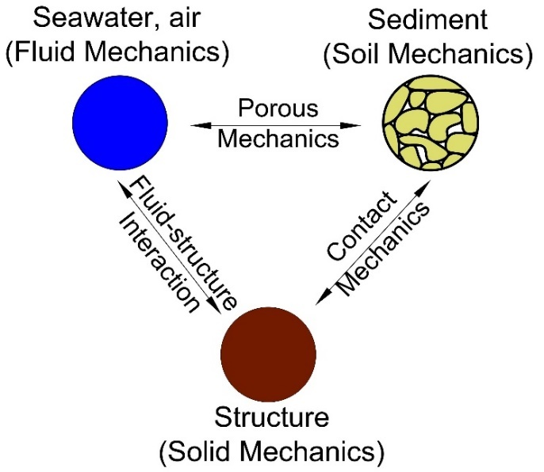

Figure Schematic of the soil-water-structure interaction

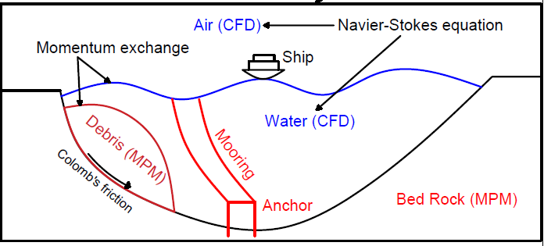

Figure Schematic of the soil-water-structure interaction

The coupled CFD-MPM model was implemented and validated within the Uintah computational framework (Tran et al., 2022) to accurately capture the triple interaction between soil, water, and structures. The CFD component is based on the implicit continuous-fluid Eulerian (ICE) method, where all state variables are located at the cell/body centers. These variables, represented as the material vector (M_r, u_r, e_r, T_r, p, ϕ_r, ν_r), encompass mass, velocity, internal energy, temperature, pressure, volume fraction, and specific volume. The MPM approach utilizes the generalized interpolation technique proposed by Bardenhagen and Kober (Bardenhagen & Kober, 2004). This technique has been validated through laboratory experiments (Tran et al., 2017a; Tran et al., 2017b) and large-scale landslide simulations (Tran & Sołowski, 2019a). To couple the MPM method with ICE, the state variables of the MPM material points, including mass, velocity, temperature, and effective stress (M_p, u_p, T_p, σ'), are mapped to the cell centers using the generalized interpolation technique. Subsequently, the governing equations are solved on the Eulerian background mesh.

By integrating these two methods, the coupled CFD-MPM model enables a comprehensive analysis of the soil-water-structure interaction, providing a robust framework for simulating the complex behavior of earthquake-induced submarine landslides. The model's validation and the utilization of established techniques ensure its accuracy and reliability in capturing the dynamic processes involved in these phenomena.

*Mass Balance Equation*

|  |  |  |
| --- | --- | --- |
|  |  | () |

*Momentum Balance Equation for fluid*

|  |  |  |
| --- | --- | --- |
|  |  | () |

*Momentum Balance Equation for solid*

|  |  |  |
| --- | --- | --- |
|  |  | () |

The last term is the momentum exchange between materials with dragging force $f_{d}$. Apart from mass and momentum balance equations, coupled CFD-MPM also solves the energy balance equations (not presented here in), all implicitly. However, we set the numerical simulations in the isothermal condition (no thermal expansion and conduction effect) for the sake of simplicity. This is also combined with the generalized Poisson’s equation to compute the fluid pressure for compressible fluid materials.

## *Momentum Exchange*

For the momentum exchange between fluid flows and porous media, we assume that the drag force $f_{d}$ (Beetstra et al., 2007) is given by:

|  |  |  |
| --- | --- | --- |
|  |  | () |

where is the average grain size of the grains, the solid volume fraction is ${}_{s}$, the fluid viscosity is ${}_{f}$, Re is the Reynolds number and the relative velocities of soil grains and fluid is $(u_{s}-u_{f})$ which is calculated as:

|  |  |  |
| --- | --- | --- |
|  |  | () |

The function is given as:

|  |  |
| --- | --- |
|  | () |

where the low Reynold coefficient is:

|  |  |
| --- | --- |
|  | () |

## *Fluid equation of state models*

The equation of state establishes relations between thermodynamics variables. For the air, the equation of state for the perfect gas is adopted while for the water, a simple linear equation of state can be written as:

|  |  |  |
| --- | --- | --- |
|  |  | () |

where reference pressure $P_{ref}$ = 1 atm = 101325 Pa, reference temperature $T_{ref}$ = 10 °C, reference density ${}_{ref}$ = 9.998 kN/m3, the bulk modulus of water $K_{f}$ = 2 GPa, and the water thermal expansion ${}_{f}$ = 0.18 °C-1. This equation matches well with the state of the water.

# Validation of the model test

## Brief description of the model test

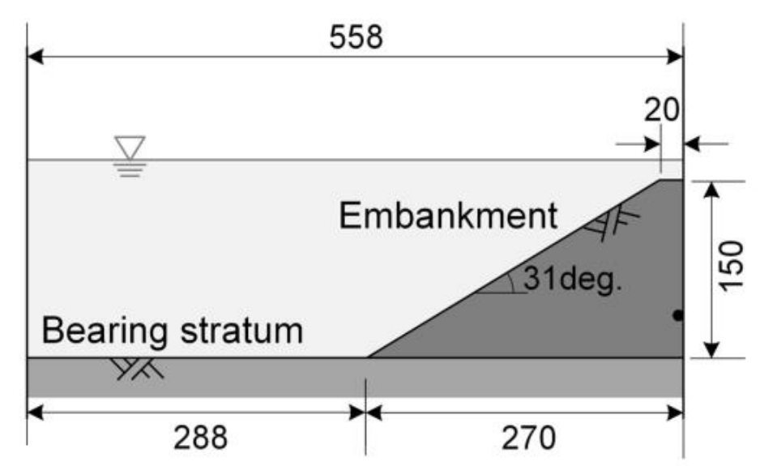

Figure Setup of the geotechnical centrifuge experiment of the earthquake induced submarine landslides (Takahashi et al., 2020)

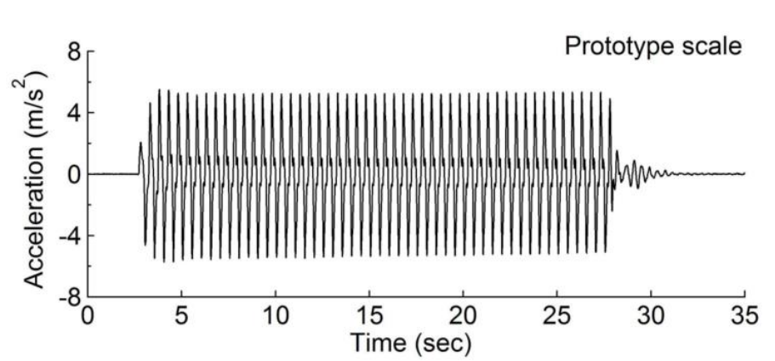

Figure Seismic wave profile of the prototype scale (Takahashi et al., 2020)

This study attempted to reproduce the results of centrifuge model test conducted by the authors (Takahashi et al., 2020). In the model test, they succeeded, for the first time, in replicating the high-speed flow of debris during a submarine landslide. Liquefaction of the ground in a centrifugal field is typically achieved using a viscous fluid as pore water to delay the dissipation of excess pore water pressure. This technique can match the time similarity ratios between the dynamic behaviour and the propagation of the pore water pressure and liquefy the ground. However, this viscous scaling increases the apparent viscosity of the soil in the liquefied state, which slows down the movement of the liquefied soil. (Takahashi et al., 2016) proposed a method called fine-grain scaling in which water is used as the pore water, but pore water pressure propagation is delayed by mixing fine grains with the sand. This technique was applied to model tests on submarine landslides to reproduce the high-velocity flow of debris.

Various model tests have been conducted, but the cross-section shown in Fig. 2 (Case KcL1) was replicated in this study. A soil mixture of kaolin clay (a mixture of silt and clay) and silica sand in the ratio of 16.7:83.3, with a relative density of 70%, was used to form a slope. This fine-grained content was adopted, as soil plasticity is more pronounced when the fine-grained content exceeds 20%. The test results showed that the higher the fine-grained content, the more fluid the soil became when liquefied. The ground was liquefied by applying the vibrations depicted in Fig. 3 (converted to a prototype scale) to the prepared ground to replicate a submarine landslide. Consequently, the slope before the vibration, that is, the red line in Fig. 4, instantly moved to the position of the blue line, and the slope collapsed. Debris flow occurred at the top of the slope, with a velocity of approximately 1.0 m/s. Excess pore water pressure was observed during the model test, confirming that the ground was completely liquefied. The vibration caused the ground to liquefy and lose its strength, allowing the slope to collapse with debris flow.

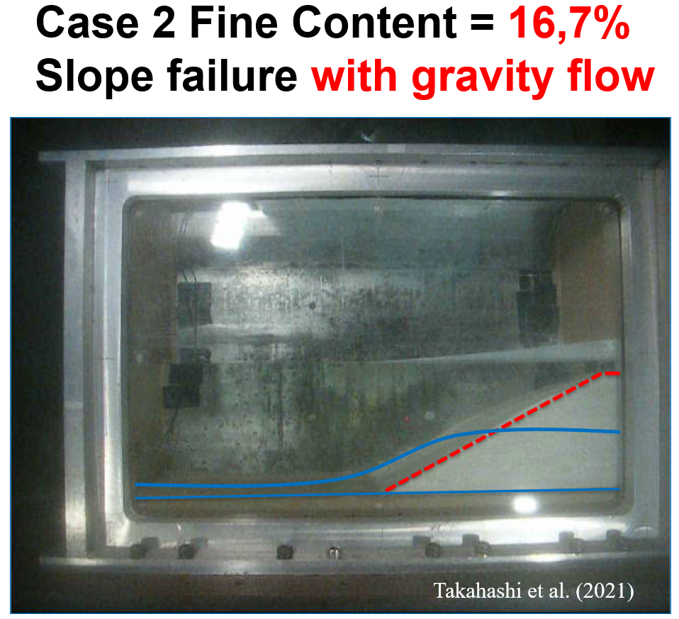

Figure Obervation from the centrifuge experiment, transition from initial slope (red line) to the gravity debris flow (blue line)

## Numerical model and soil parameters



Figure . Numerical simulation with contour of the pore water pressure

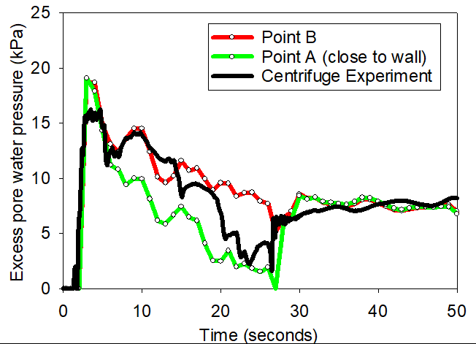

Figure . Comparison between experiment and numerical model in terms of excess pore water pressure

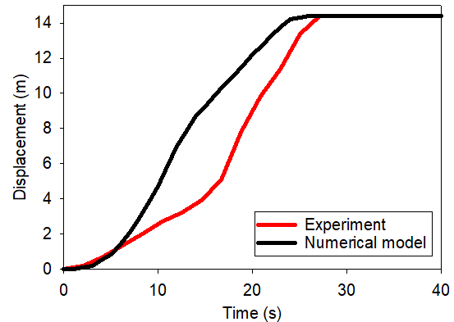

Figure . Comparison between experiment and numerical model in terms of displacement of the toe

# Role of permeability on the failure mechanism

This study considers the base case shown in Figure 9. A 20-meter-high slope with a 45-degree face is placed within a horizontal and vertical structure (plane box). This structure was used as a shaking table to apply earthquake loading. To simplify earthquake loading, we simulated ground shaking for 20 seconds at a peak ground acceleration of 1g and a frequency of 2Hz (Figure 10). Ground motion is expressed in terms of velocity. A magnitude 6 or greater earthquake can produce a similar frequency and peak ground acceleration. To highlight the role of hydraulic conductivity on the failure mechanism of earthquake-induced submarine landslides, two simulations are analysed: (1) A low hydraulic conductivity case, to mimic clay behaviour and (2) a high hydraulic conductivity case to mimic the sand behaviour. The hydraulic conductivity is calculated based on the size of the soil grain, the viscosity of the fluid, and the porosity.

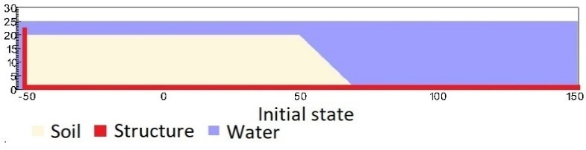

Figure . Geometry of the base case slope

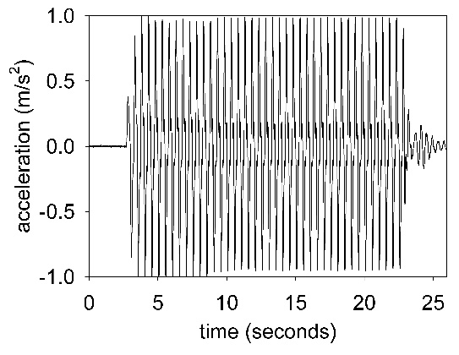

Figure . Ground acceleration profile, frequency of 2Hz and magnitude of 1g

Under gravity, the density of the water at the water surface is 9.998 kN/m3 at the pressure of 1 atm and at the temperature of 10 °C. At the top boundary, the air has a density of 1.17 kg/m3 at the atmospheric pressure of 1 atm. At 10 Celsius degrees, air and water have viscosity of 18.45e-3 mPa s and 1 mPa s respectively. On all boundary faces, the symmetric boundary condition is imposed, while the Neuman boundary condition is imposed at the top boundary for pressure (dp/dx = 0 kPa) and density (d/dx = 0 kg/m3). The mesh size is 0.25 x 025m with 300852 element cells and 142316 material points. We consider constant temperature in the entire domain (isothermal condition) and we do not calculate the thermal expansion and thermal conduction in the numerical simulations.

## Role of permeability on the runout of the slope

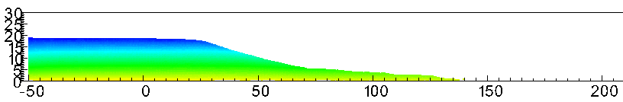

1. **Simulation with soil parameter adopted from centrifuge validation and using high permeability. Color represent pore water pressure**

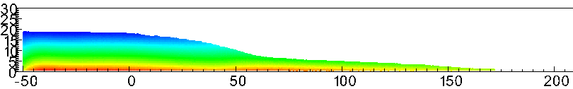

1. **Simulation with soil parameter adopted from centrifuge validation and using low permeability. Color represent pore water pressure**

Figure . Influence of permeability, on top (a) the gravity debris flow stops running and, on the bottom, (b) the gravity debris flow still running due to slow dissipation of the excess pore water pressure in sediment

## Role of permeability on the failure mechanism

Two grain sizes are selected for the numerical analysis (1) $D_{p}$ = 0.5 mm and (2) $D_{p}$ = 0.0001 mm to mimic the hydraulic conductivity of sand and clay.

We compare simulations with the same input parameters except for the grain size Dp. For both cases, we demonstrate the entire process and the mechanism of earthquake-induced submarine landslides and discuss to the differences in the mechanisms.

The initial stress condition is generated by running the simulations for 10 seconds with every high hydraulic conductivity ($D_{p}$ = 1m). The slope is fully consolidated after 10s under the gravity to create the initial effective stress and initial pore water pressure .

## *Soil Models*

A non-associated Mohr-Coulomb model is used for the soil. Because the Young's modulus has negligible effect on the simulations (in which plastic deformation is dominant) based on sensitivity analysis, the Young's modulus is set to be 10 kPa and Poisson's ratio is 0.3 with zero cohesion. The mobilized friction angle ${}_{m}^{ '}$ is governed following the softening curve (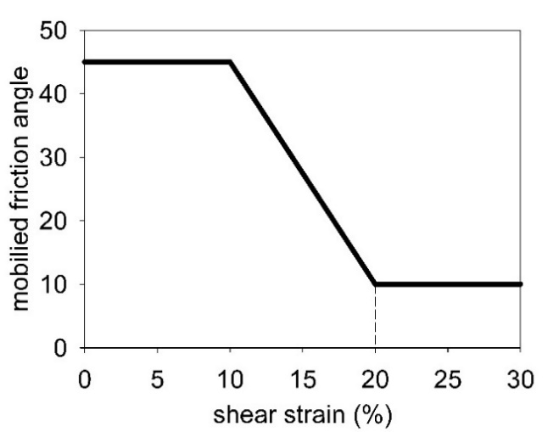

Figure 12) with the peak friction angle ${}_{p}^{ '}$ of 45 degrees and the residual friction angle ${}_{r}^{ '}$ of 10 degrees. The mobilized dilatancy angle is calculated from the Rowe-stress dilatancy as follow:

|  |  |  |
| --- | --- | --- |
|  |  | () |



Figure . Mobilized friction angle in Mohr Coulomb

The contact between horizontal plane and the soil is the frictional contact with a friction coefficient of 0.1. No artificial damping is applied in the simulation. The contact between vertical plane and the sand is considered as smooth.

1. *Sand flow slide (high permeability soil)*

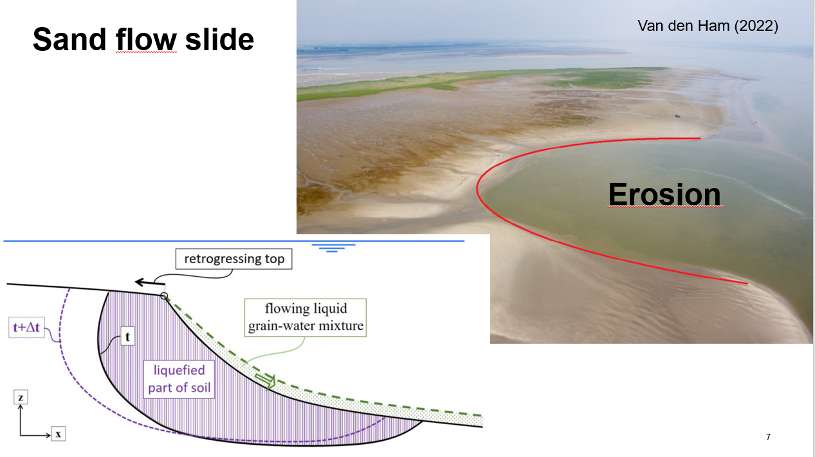

Figure . Sand flow slide mechanism

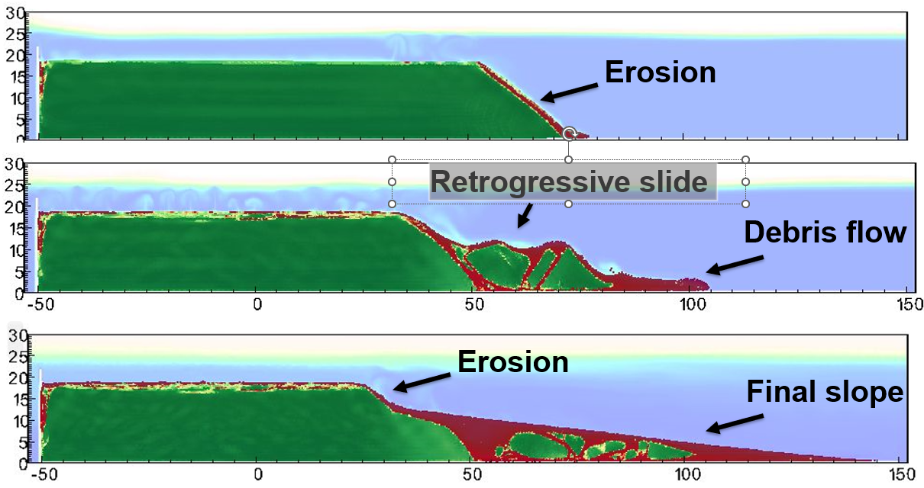

Figure . Simulation of sand flow slide

**

Figure . Pore water pressure



Figure . Mean effective stress

1. *Clay spreading (low permeability soil)*

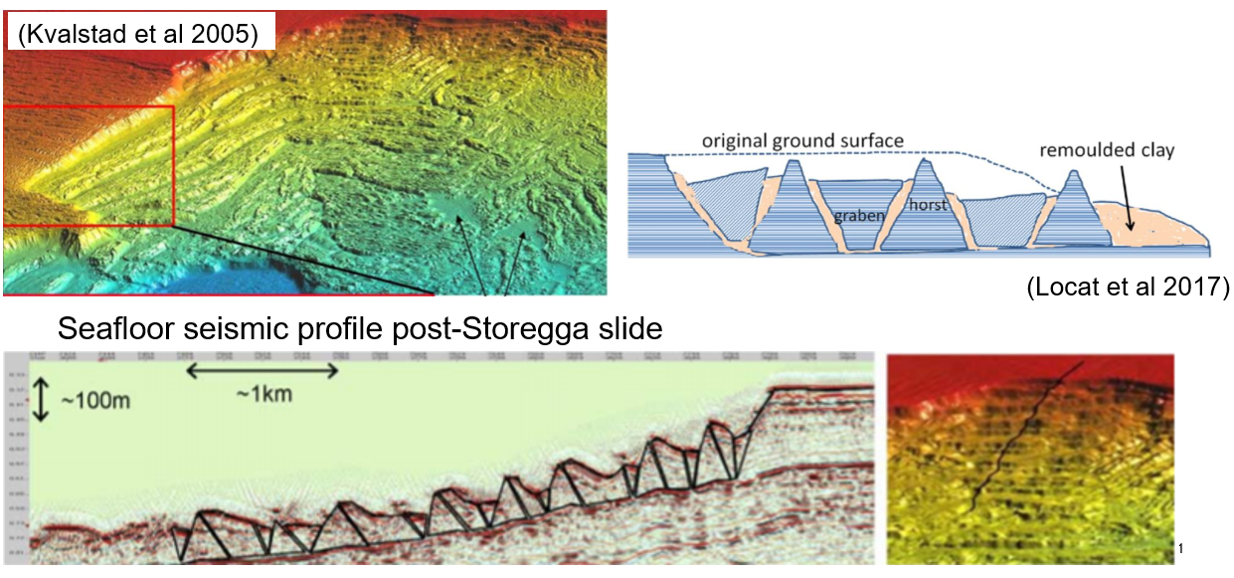

Figure . Clay spreading mechanism



Figure . Shear strain

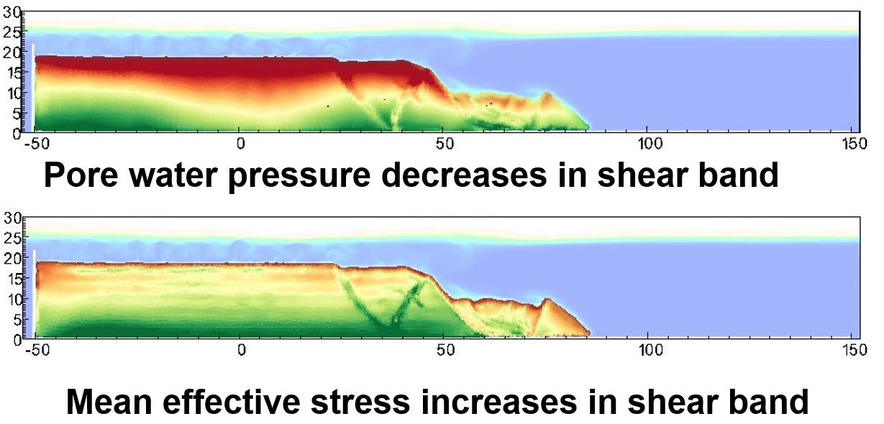

Figure . Soil dilation in the shear band

# Conclusion

Since a better integrated understanding of the multiple mechanisms and multi-phased physics of submarine landslides is important globally (Sassa et al., 2022), it is hoped that the findings and conclusions obtained in the present study may facilitate such a multi-disaster risk reduction from submarine landslides.

# Acknowledgements

The research received support from the European Union’s Horizon 2020 research and innovation program under the grant agreement 101022007. The computations were performed on High Performance Computing resources provided by UNINETT Sigma2 - the National Infrastructure for High Performance Computing and Data Storage in Norway. We would like to express our gratitude to the Soil Dynamics Group of the Port and Airport Research Institute in Yokosuka, Japan for their generous hospitality during our research visits in Japan.

# Code availability

Instructions for replicating the numerical results in this paper are given at the open-source platform GitHub. Also, the open-source code is shared in this platform for interested users to take up and make use of the results.

# Reference

Bandara, S., & Soga, K. (2015). Coupling of soil deformation and pore fluid flow using material point method (vol 663, pg 199, 2015). *Computers and Geotechnics*, *65*, 302-302. <https://doi.org/10.1016/j.compgeo.2014.12.007>

Capone, T., Panizzo, A., & Monaghan, J. (2010). SPH modelling of water waves generated by submarine landslides. *Journal ofHydraulic Research*, *48*(1), 80-84.

Dey, R., Hawlader, C., Phillips, R., & Soga, K. (2016). Numerical modelling of submarine landslides with sensitive clay layers. *Géotechnique*, *66*(6), 454-468.

Harbitz, C. B., Lovholt, F., & Bungum, H. (2014). Submarine landslide tsunamis: how extreme and how likely? *Natural Hazards*, *72*(3), 1341-1374. <https://doi.org/10.1007/s11069-013-0681-3>

Locat, J., & Lee, H. J. (2002). Submarine landslides: advances and challenges. *Canadian Geotechnical Journal*, *39*(1), 193-212. <https://doi.org/10.1139/T01-089>

Puzrin, A. M. (2016). Simple criteria for ploughing and runout in post-failure evolution of submarine landslides. *Canadian Geotechnical Journal*, *53*(8), 1305-1314. <https://doi.org/10.1139/cgj-2015-0582>

Sassa, S., Grilli, S. T., Tappin, D. R., Sassa, K., Karnawati, D., Gusiakov, V. K., & Lovholt, F. (2022). Understanding and reducing the disaster risk of landslide-induced tsunamis: a short summary of the panel discussion in the World Tsunami Awareness Day Special Event of the Fifth World Landslide Forum. *Landslides*, *19*(2), 533-535. <https://doi.org/10.1007/s10346-021-01819-x>

Sassa, S., & Sekiguchi, H. (2010). Liqsedflow: Role of Two-Phase Physics in Subaqueous Sediment Gravity Flows. *Soils and Foundations*, *50*(4), 495-504. <https://doi.org/DOI> 10.3208/sandf.50.495

Sassa, S., & Sekiguchi, H. (2012). Dynamics of Submarine Liquefied Sediment Flows: Theory, Experiments and Analysis of Field Behavior. *Submarine Mass Movements and Their Consequences*, *31*, 405-+. <https://doi.org/10.1007/978-94-007-2162-3_36>

Sassa, S., & Takagawa, T. (2019). Liquefied gravity flow-induced tsunami: first evidence and comparison from the 2018 Indonesia Sulawesi earthquake and tsunami disasters. *Landslides*, *16*(1), 195-200. <https://doi.org/10.1007/s10346-018-1114-x>

Shi, J. J., Zhang, W., Wang, B., Li, C. Y., & Pan, B. (2020). Simulation of a Submarine Landslide Using the Coupled Material Point Method. *Mathematical Problems in Engineering*, *2020*. <https://doi.org/Artn> 4392581

10.1155/2020/4392581

Takahashi, H., Fujii, N., & Sassa, S. (2020). Centrifuge model tests of earthquake-induced submarine landslide. *International Journal of Physical Modelling in Geotechnics*, *20*(4), 254-266. <https://doi.org/10.1680/jphmg.18.00048>

Takahashi, H., Takahashi, N., Morikawa, Y., Towhata, I., & Takano, D. (2016). Efficacy of pile-type improvement against lateral flow of liquefied ground. *Geotechnique*, *66*(8), 617-626. <https://doi.org/10.1680/jgeot.14.P.238>

Tran, Q. A., Berzins, M., & Sołowski, W. (2019). An improved moving least squares method for the Material Point Method. International Conference on the Material Point Method for Modelling Soil-Water-Structure Interaction, Cambridge, UK.

Tran, Q. A., Grimstad, G., & Ghoreishian Amiri, S. A. (2022). MPMICE: A hybrid MPM-CFD model for simulating coupled problems in porous media. Application to earthquake-induced submarine landslides. *arXiv preprint*.

Tran, Q. A., & Sołowski, W. (2019). Temporal and null-space filter for the material point method. *International Journal for Numerical Methods in Engineering*, *120*(3), 328-360.

Tran, Q. A., Wobbes, E. D., Sołowski, W., Moller, M., & Vuik, C. (2019). Moving least squares reconstruction for B-spline Material Point Method. International Conference on the Material Point Method for Modelling Soil-Water-Structure Interaction, Cambridge, UK.

Zhang, X., Onate, E., Torres, S. A. G., Bleyer, J., & Krabbenhoft, K. (2019). A unified Lagrangian formulation for solid and fluid dynamics and its possibility for modelling submarine landslides and their consequences. *Computer methods in applied mechanics and engineering*, *343*, 314-338.

Zheng, X., Pisano, F., Vardon, P., & Hicks, M. A. (2021). An explicit stabilised material point method for coupled hydromechanical problems in two-phase porous media. *Computers and Geotechnics*, *135*, 104112.